nFinia Digital Banking | Summerville Credit Union | Member User Guide
Cards
Module: Banking › Cards

01 PRODUCT SUMMARY

The Cards page is your central hub for all enrolled debit and credit cards. At a glance you can see each card's masked number, expiry, CVV, current balance, available credit, and Card Status. From here you can navigate directly to Card Controls, Set PIN, Deactivate / Replace Card, or View Account — all without leaving a single screen. You can also filter by account or open a new card application from this page.

At a Glance
Feature Name | Cards
Module Location | Banking › Cards
Who Can Use | All nFinia Digital Banking members with an enrolled card
Cards Shown | All active debit and credit cards linked to your accounts
Filter Options | All Cards dropdown, Select Account dropdown
Quick Actions | Card Controls, Set PIN, Deactivate / Replace Card, View Account
Card Status Toggle | Instantly block or unblock a card (On = active, Off = blocked)
Open New Card | Shortcut to apply for or order a new card
Availability | 24 / 7 — via web or mobile

02 KEY USE CASES

Use Case | Member Goal | Steps | Outcome
View all cards | See every enrolled card and its current status in one place | Navigate to Banking › Cards | All cards listed with balance, status, and quick-action links
Check card balance | See available credit and current balance without logging into a separate account | Open the Cards page and read the balance shown below the card image | Balance and available credit visible on the card tile
Block or unblock a card | Instantly suspend or re-enable a card | Toggle the Card Status switch on the card tile; confirm the action | Card status changes immediately
Reveal card number and CVV | View masked card details securely | Click "Reveal card number and CVV" link on the card tile | Full card number, expiry, and CVV displayed temporarily
Navigate to Card Controls | Access spending limits, usage controls, alerts, or location controls | Click Card Controls at the bottom of a card tile | Taken directly to the Card Controls section for that card
Filter cards by account | Narrow the list to cards linked to one account | Use the Select Account dropdown at the top of the page | Only cards for that account are shown
Open a new card | Start the process of adding a new card | Click Open New Card at the top right of the page | Directed to the new card application or order flow

03 STEP-BY-STEP GUIDE

📍 Navigation path: Banking › Cards

Step 1 Navigate to the Cards Page
From the nFinia top navigation bar, click Cards. The Cards page loads all your enrolled debit and credit cards as individual tiles.
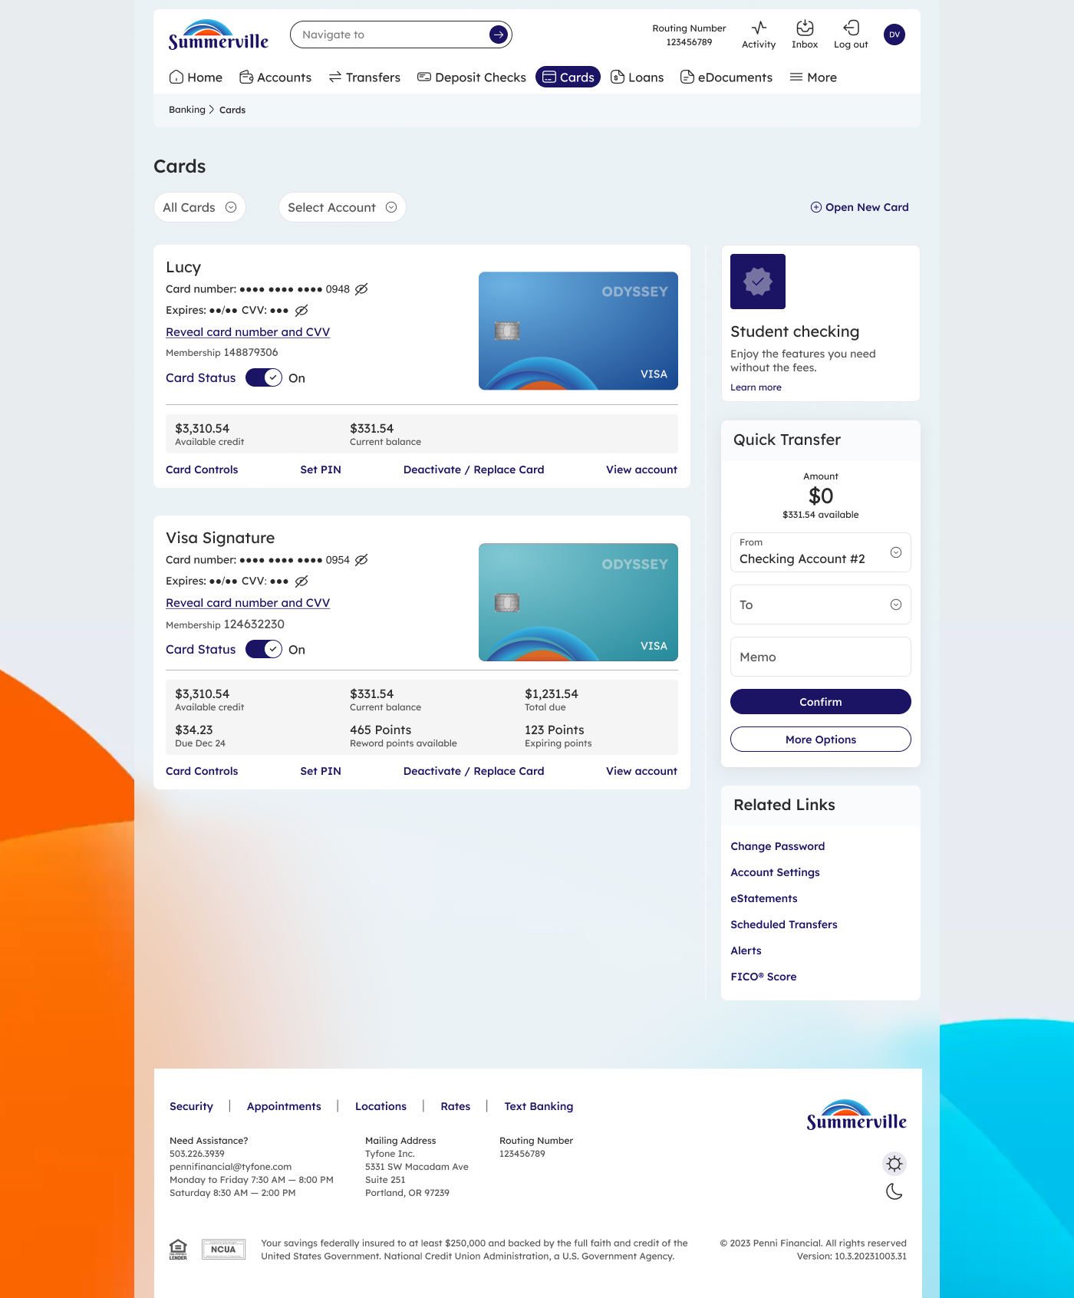

Step 2 Read Your Card Tiles
Each card tile shows everything you need to know about that card. The table below explains every element you will see on a card tile.

Card Tile Anatomy
Card Tile Element | What It Shows | Debit vs. Credit
Card name | The name you or the credit union has given to this card (e.g. "Lucy", "Visa Signature") | Same for both card types
Card number | Masked card number (e.g. •••• •••• •••• 0948). Click "Reveal" to view in full | Same for both card types
Expiry / CVV | Masked expiry date and CVV. Revealed via the same link as card number | Same for both card types
Membership | Membership number linked to this card | Same for both card types
Card Status toggle | "On" = card is active. "Off" = card is blocked. Toggle to change instantly | Same for both card types
Available credit | How much credit is still available to spend | Debit: shows available balance. Credit: shows credit limit remaining
Current balance | Total amount currently owed or pending on the card | Debit: pending/posted balance. Credit: statement balance
Total due | The next payment amount due | Credit cards only — not shown on debit cards
Due date | The date the next payment must be made | Credit cards only — not shown on debit cards
Reward points | Accumulated reward points available to redeem | Credit cards only (if rewards-enabled)
Expiring points | Points that will expire soon | Credit cards only (if rewards-enabled)
Card Controls | Opens Card Controls for this card (spending limits, alerts, location, usage) | Same for both card types
Set PIN | Opens the Set PIN flow for this card | Same for both card types
Deactivate / Replace Card | Opens the card deactivation or replacement flow | Same for both card types
View account | Navigates to the full account view for the account linked to this card | Same for both card types

Step 3 Filter Your Cards
If you have multiple cards or accounts, use the All Cards and Select Account dropdowns at the top of the page to narrow the list. Select a specific account to show only cards linked to that account.
ℹ️ Tip: The "All Cards" dropdown also lets you filter by card type if you have both debit and credit cards enrolled.

Step 4 Use Quick Actions
Each card tile has four quick-action links at the bottom. You do not need to open the card's full detail page to reach any of these features — just click the link directly from the Cards list.

Card Controls | Opens spending limits, usage controls, card alerts, and location controls for the selected card
Set PIN | Launches the guided flow to create or change the card's PIN
Deactivate / Replace Card | Starts the process to permanently deactivate or request a replacement card
View account | Opens the full account transaction history and details for the account linked to this card

ℹ️ Tip: If a card shows Card Status: Off, it means the card is currently blocked. Click the toggle and confirm to re-enable it immediately.

